Setting up a local Docker registry

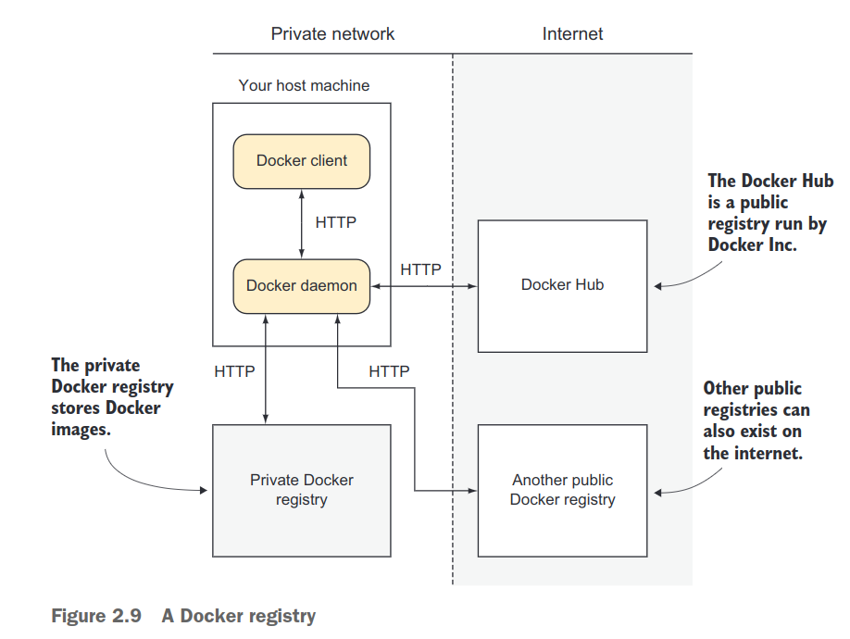

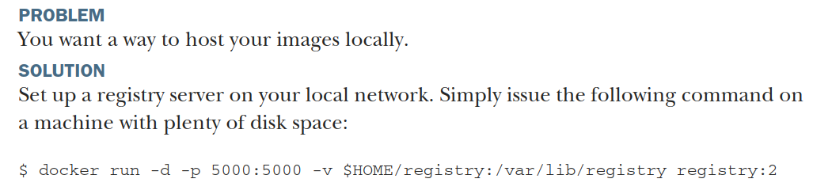

sudo docker run -d -p 5000:5000 -v $HOME/demo:/var/lib/registry registry:latest
clear This command makes the registry available on port 5000 of the Docker host(-p 5000:5000). With the -v flag, it makes the registry folder on your host(/var/lib/registry) available in the container as $HOME/registry. The registry’s fileswill therefore be stored on the host in the /var/lib/registry folder.
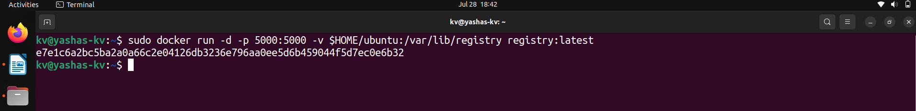

On all of the machines that you want to access this registry, add the following to your daemon.json (where HOSTNAME is the hostname or IP address of your new reg-istry server): "insecure-registries":["localhost:port"]

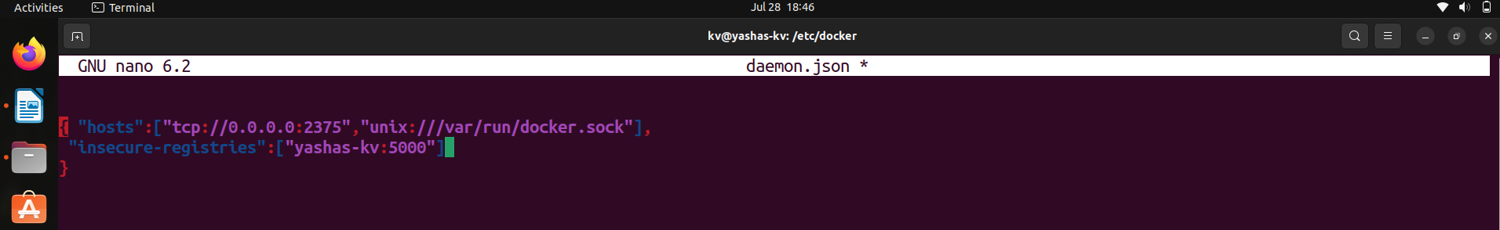
To push Create a image with docker tag :
docker tag image localhost:port/image



To push :
docker push HOSTNAME:5000/image:tag

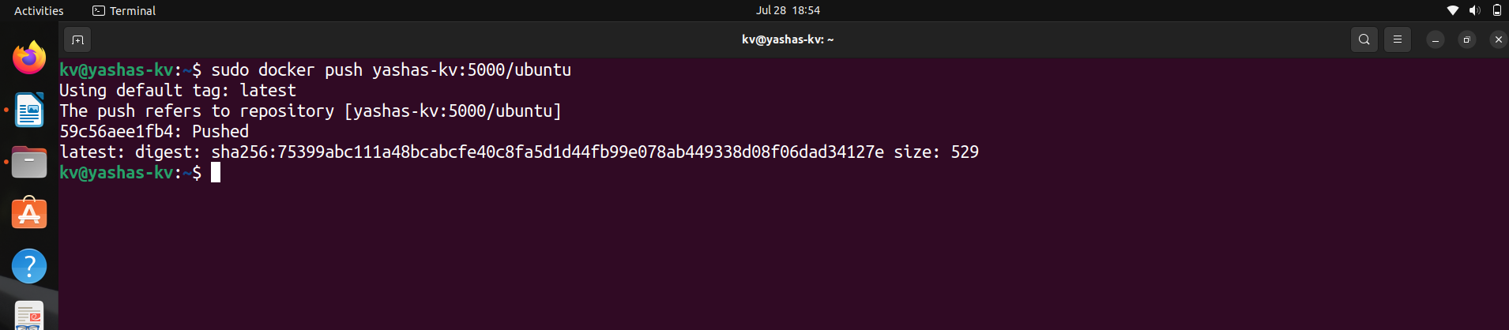

To pull
docker pull HOSTNAME:5000/image:tag


You can vefiry by removing the image using docker rmi cmd and pull the image again.

